IT24101809 Lab sheet 07 Ferdinando M.D.S

1.

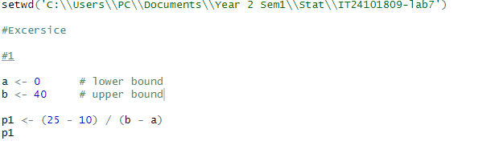

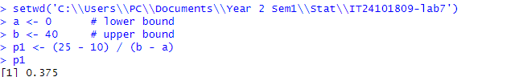

2.

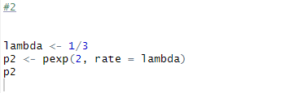



3.

(i)

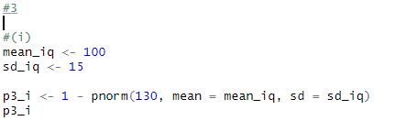

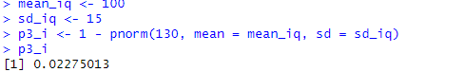

(ii)

